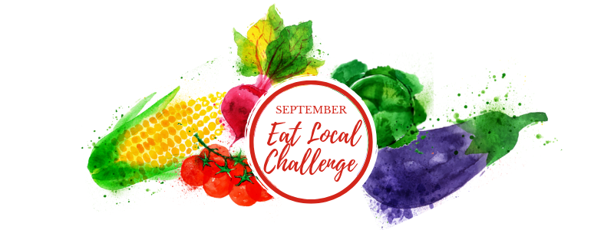

Newsletter Blurb

Option 1: This September marks the beginning of the 4th Annual Eat Local Challenge, and this year, our partners at Buy Fresh Buy Local Central Illinois are shaking things up with a month long photo scavenger hunt to connect you with more local food and farms. To play just download the Scavify App and join the hunt: Eat Local Challenge. You’ll receive fun photo challenges, great resources, seasonal recipes, and a chance to win $200 to your favorite local farm or farmers market (like us!). For more info, visit their website at www.buyfreshbuylocalcentralillinois.org

Option 2: September is almost here, and it’s one of the most abundant times of the year at our farmer’s market. Unfortunately, it’s also the time when attendance and sales start slowing down. You can help farms across Central Illinois beat the “September Slump” by taking the September Eat Local Challenge. a month long photo scavenger hunt to connect you with more local food and farms. To play just download the Scavify App and join the hunt: Eat Local Challenge. You’ll receive fun photo challenges, great resources, seasonal recipes, and a chance to win $200 to your favorite local farm or farmers market (like us!). For more info, visit their website at www.buyfreshbuylocalcentralillinois.org

Customizable Social Media for Markets (suggested to post at least once a week starting in Mid-August)

1. The #SeptemberEatLocalChallenge is starting soon, a month long photo challenge to connect you with local food and farms. To play just download the Scavify App, sign up, and join the hunt: EatLocalChallenge. You’ll receive fun photo challenges, great resources, recipes, and a chance to win $200 to your favorite local farm or farmers market (like us!). Stop by (name of Market) on (date/time of Market) and snap a photo with one of our vendors to complete the first challenge! #septembereatlocalchallenge #buyfreshbuylocal #photoscavengerhunt
Post a photo of shoppers posing with a farmer at your farmers market

2. Did you know that September is one of the most abundant months of the year? That means it’s also the best time of the year to shop at the farmers market and score some deals. This week you can find everything from ______ to _______. Unfortunately, it’s also the time of year when folks stop shopping at the farmers market. Help us beat the “September Slump” and join us every (time and date of your market) at (location of your market). And right now is the best time to shop local during the #SeptemberEatLocal Challenge, a month long photo challenge to connect you with local food and farms. Just download the Scavify App and join the hunt: Eat Local Challenge. You’ll receive fun photo challenges, great resources, recipes, and a chance to win $200 to your favorite farm or farmers market (like us!). #SeptemberEatLocalChallenge #photoscavengerhunt #buyfreshbuylocal
Post a photo of abundant produce at your market

3. If your market is producer only: Did you know that our farmers market is “producer only”? That means you can be certain that everything you see at the Market was raised by the farmers standing behind the booth. We take great care to visit our farms and get to know our farmers so that you can trust the integrity of our Market-- but we encourage you to get to know them too! And right now is the best time to get to know your farmers during the #SeptemberEatLocal Challenge, a month long photo challenge to connect you with local food and farms. Just download the Scavify App and join the hunt: Eat Local Challenge. You’ll receive fun photo challenges, great resources, recipes, and a chance to win $200 to your favorite farm or farmers market (like us!). #SeptemberEatLocalChallenge #photoscavengerhunt #buyfreshbuylocal
Post a photo of a vendor, or multiple vendors at your market

4. If your market has a SNAP/LINK program: Did you know that our farmers market accepts LINK Cards? Check out our farmers market tent on (time and date of your market) to find out how you can use your LINK card to purchase fresh fruits and veggies straight from local farmers. And right now is the best time to shop local during the #SeptemberEatLocal Challenge, a month long photo challenge to connect you with local food and farms. Just download the Scavify App and join the hunt: Eat Local Challenge. You’ll receive fun photo challenges, great resources, recipes, and a chance to win $200 to your favorite farm or farmers market (like us!). #SeptemberEatLocalChallenge #photoscavengerhunt #buyfreshbuylocal
Post a photo of your SNAP/LINK employee/volunteer holding tokens and signage

5. If your market has a SNAP/LINK Match program: Did you know that our farmers market has a SNAP/LINK match program?! Swipe your card for $(highest matched amount) and get another $(highest matched amount) to spend on fresh fruits and vegetables straight from local farmers. Right now is during the #SeptemberEatLocal Challenge is the best time to take advantage of the SNAP/LINK match program. It’s a month long photo challenge to connect you with local food and farms. Just download the Scavify App and join the hunt: Eat Local Challenge. You’ll receive fun photo challenges, great resources, recipes, and a chance to win $200 to your favorite farm or farmers market (like us!). #SeptemberEatLocalChallenge #photoscavengerhunt #buyfreshbuylocal
Post a photo of your SNAP/LINK employee/volunteer holding tokens and signage

6. Did you know that our farmers market supports over (# of farmers)! Stop by every (time and date of market) at (location of market) to pick up amazingly fresh produce and proteins like _____, _____, and _____ from our wonderful vendors. Ane right now is the perfect time to meet our vendors and shop local during the #SeptemberEatLocal Challenge, a month long photo challenge to connect you with local food and farms. Just download the Scavify App and join the hunt: Eat Local Challenge. You’ll receive fun photo challenges, great resources, recipes, and a chance to win $200 to your favorite farm or farmers market (like us!). #SeptemberEatLocalChallenge #photoscavengerhunt #buyfreshbuylocal

